Task 3: Sass Basics

What is Sass?
Sass (Syntactically Awesome Stylesheets) is a CSS preprocessor that extends the functionality of regular CSS. It adds features such as variables, nesting, partials, mixins, and functions, which allow developers to write cleaner, more maintainable, and scalable stylesheets. Sass files are written using .scss (Sassy CSS) or .sass (indented syntax) and then compiled into standard CSS that browsers can understand.

Key Differences Between Sass and Regular CSS:
- Variables: Sass allows you to define reusable variables for colors, font sizes, etc.
- Nesting: You can nest CSS selectors inside each other, reflecting the HTML structure.
- Partials & Imports: Sass allows splitting styles into smaller files (partials) and importing them into a main stylesheet.
- Mixins: You can create reusable chunks of CSS code with mixins, which accept arguments.
- Functions & Operations: Sass provides functions (for color manipulation, etc.) and allows mathematical operations directly in the stylesheet.

Example: A Simple Sass File Demonstrating Nesting, Partials, and Imports

Project Structure:
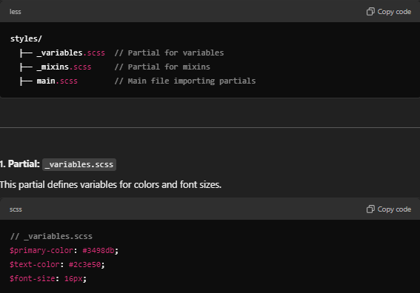
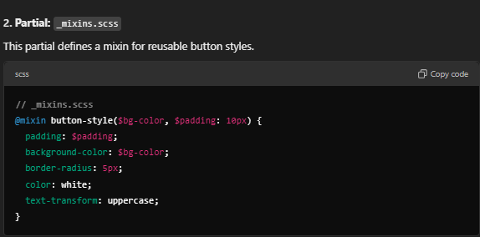

3. Main File: main.scss
This file imports the partials and demonstrates nesting in styles.
// main.scss

// Import partials
@import 'variables';
@import 'mixins';

body {
background-color: $primary-color;
color: $text-color;
font-size: $font-size;

// Nested styles for a navigation bar
nav {
background-color: darken($primary-color, 10%);
ul {
list-style-type: none;

li {
display: inline-block;
padding: 10px;

a {
color: white;
text-decoration: none;
&:hover {
text-decoration: underline;
}
}
}
}
}
}

// Button styles using mixin
.button {
@include button-style($primary-color);
}

.alert {
@include button-style(#e74c3c, 15px);
}

Resulting CSS After Compilation:
When you compile the main.scss file using Sass, the output in CSS looks like this:
/* Compiled CSS */
body {
background-color: #3498db;
color: #2c3e50;
font-size: 16px;
}

nav {
background-color: #2b87c3;
}

nav ul {
list-style-type: none;
}

nav ul li {
display: inline-block;
padding: 10px;
}

nav ul li a {
color: white;
text-decoration: none;
}

nav ul li a:hover {
text-decoration: underline;
}

.button {
padding: 10px;
background-color: #3498db;
border-radius: 5px;
color: white;
text-transform: uppercase;
}

.alert {
padding: 15px;
background-color: #e74c3c;
border-radius: 5px;
color: white;
text-transform: uppercase;
}

Notable Differences from Standard CSS:
- Nesting: In Sass, selectors like nav ul li a:hover are nested, reflecting the structure of the HTML. In standard CSS, you would write each selector separately.
  - Example:
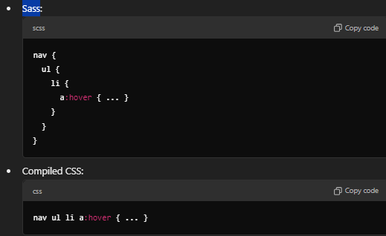
- Partials and Imports: The @import rule in Sass allows splitting code into smaller, reusable parts (partials). In regular CSS, imports typically slow down page load times because they are fetched via HTTP. In Sass, however, partials are compiled into a single CSS file.
- Variables and Mixins: The $primary-color and $text-color variables in Sass are replaced with actual color values in the compiled CSS. Similarly, the @mixin for buttons is expanded into CSS rules, eliminating the need to repeat code across multiple selectors.

Benefits of Using Sass over Regular CSS:
- Maintainability: Variables, mixins, and partials make it easier to manage and update styles across large projects.
- Readability: Nesting makes the styles mirror the HTML structure, improving readability.
- Reusability: Mixins allow the reuse of common patterns (like button styles) across different components without repeating code.

